**4) Pattern Matching using :: PIPE Character**

# Pattern Matching using PIPE

import re

st = ' I uses softball for my software using softword '

reobj = re.compile(**'soft(key|ball|ware)')**

res = reobj.search(st)

if(res == None):

print(' Not Found ')

else:

print(' Found ', res.group())

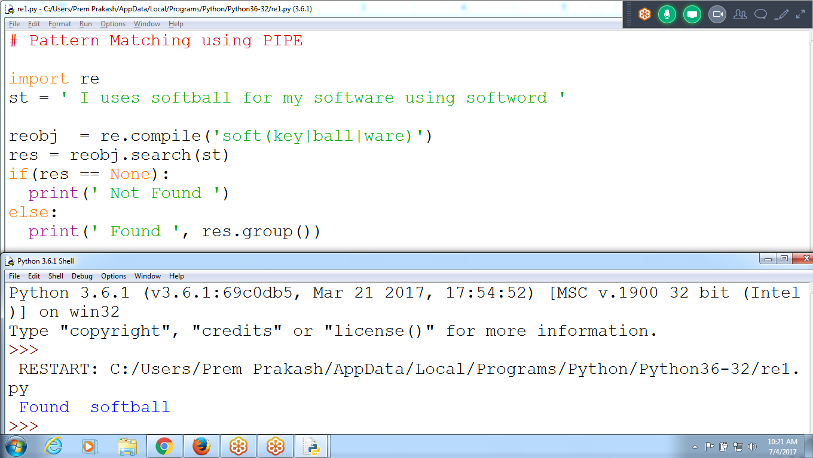

**6) Pattern Matching OPtional CODE in phone number**

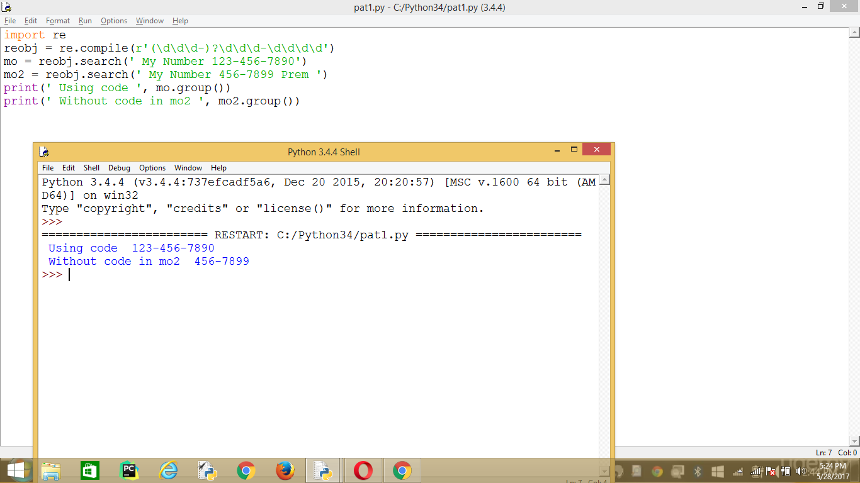

**Greedy and Non Greedy Values**

**? Represents 0 or 1 time only**  Not for multiple Times

**\* represents :: zero or More times**

**+ Represents : one or More time**

# IN between bat and man, 'wo' may exists zero or one time

import re

st = ' I am batan batman batman man bat'

reobj = re.compile('batman')

print(reobj.search(st))

reobj2 = re.compile('bat(wo)?man')

print(reobj2.search(st))

st2 = ' I am batwoman batman batwoman man bat'

reobj3 = re.compile('bat**(wo)?**man')

print(reobj3.search(st2))

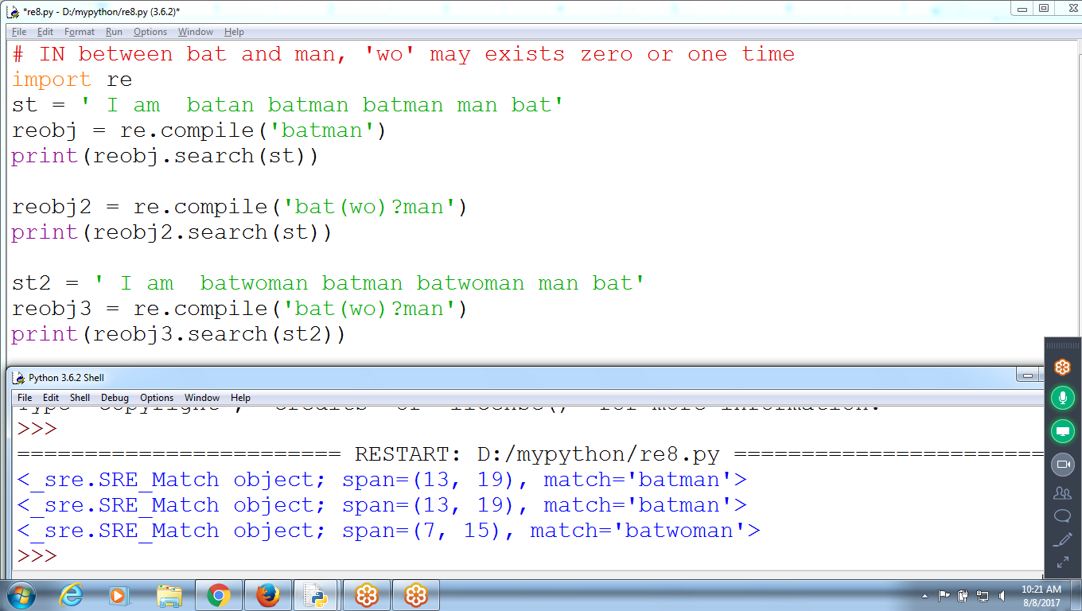

**7) * represents :: zero or More times**

import re

st2 = 'I am batwowowoman batman batwoman man bat'

reobj3 = re.compile('bat(wo)*man')

print(reobj3.search(st2))

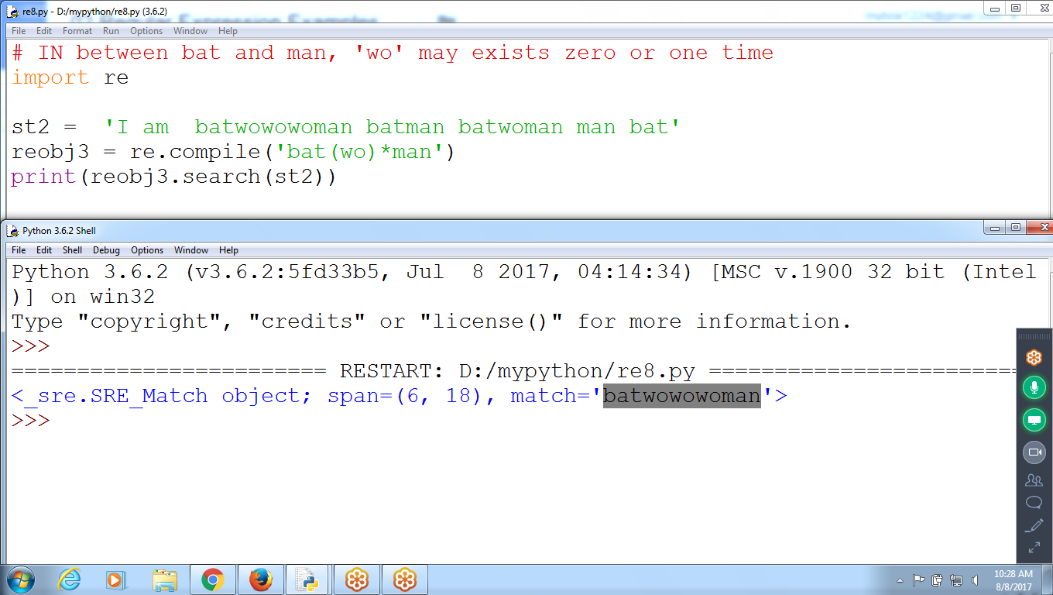

**8)**

**? : Zero or one**

**\* : Zero or More**

**+ Represents : one or More time (compulsory)**

import re

st2 = 'I am batman batman batman man bat'

reobj2 = re.compile('bat(wo)+man')

print(reobj2.search(st2)) # None

st3 = 'I am batman batwowoman batman man bat'

reobj3 = re.compile('bat(**wo**)+man')

print(reobj3.search(st3)) # Position

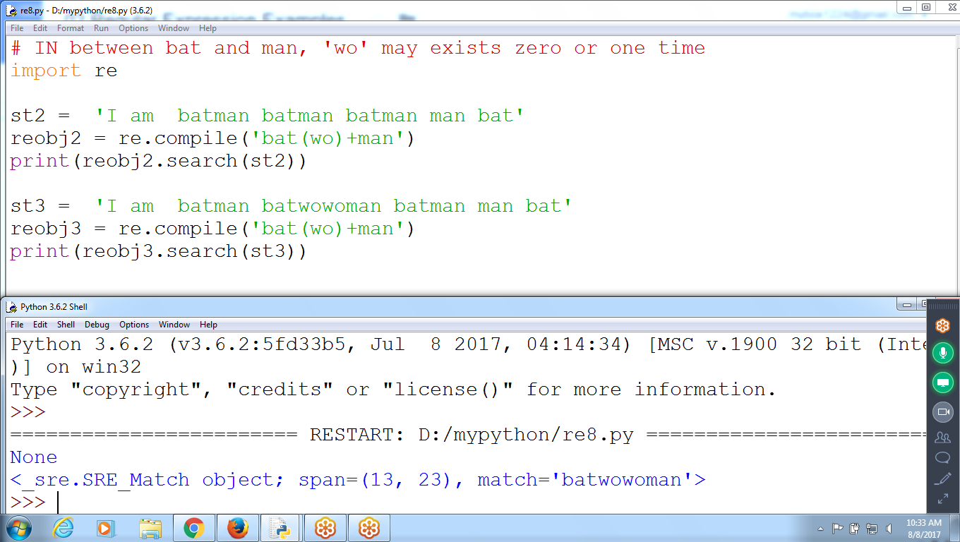

>>> reobj = re.compile('bat(wo)+man')

>>> es = reobj.search(' Hello i am batman Good Morning ')

>>> print(es)

None

>>>

>>>

>>> res = reobj.search(' Hello i am batwowowoman Good Morning ')

>>> print(res)

<_sre.SRE_Match object; span=(12, 24), match='batwowowoman'>

>>>

**\* : Zero or More**

reobj = re.compile('bat(wo)*man')

batman : T

Batman : None

batwoooman : None

batwowowoman : True

? : Zero or one

reobj = re.compile('bat(wo)?man')

batman : T

Batman : None

batwoooman : None

batwowowoman : None

+ : one or More

reobj = re.compile('bat(wo)+man')

batman : None

Batman : None

batwoooman : None

batwowowoman : True

**9) ABout ?*+**

Checking for ?*+

import re

reobj = re.compile(r'\?\*\+')

mo= reobj.search(' We learned ?*+ in python ')

print(mo.group())

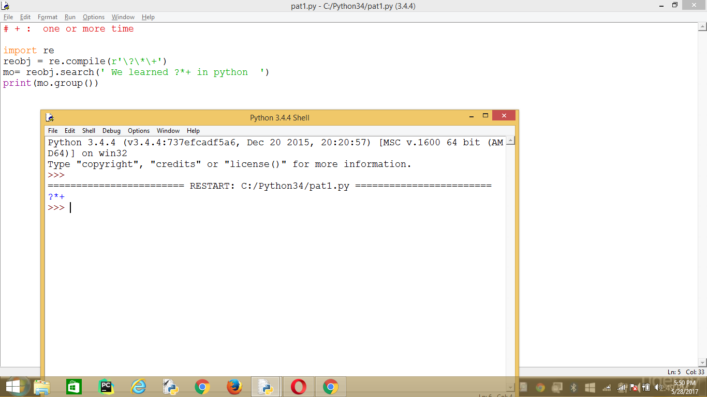

Not Existing :: ?*+

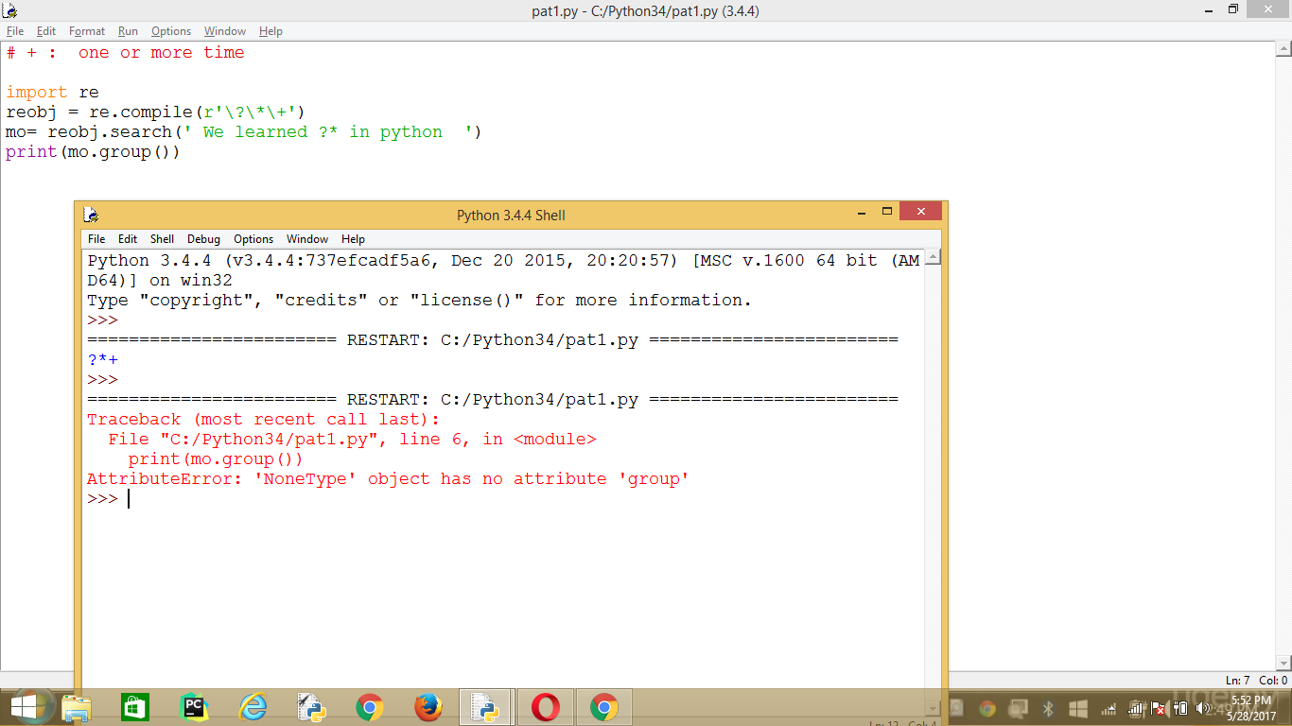

# + represents one or more time expression character

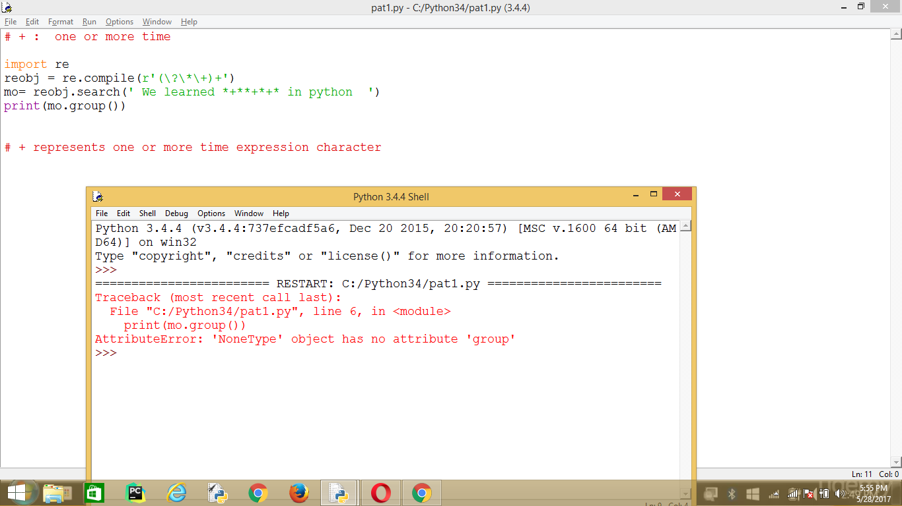

**10) Multiple TImes {}**

**import re**

**st = 'Hello karthik hahaha anand ha '**

**reobj = re.compile('hahaha')**

**print(reobj.search(st))**

**reobj2 = re.compile('(ha){3}')**

**print(reobj2.search(st))**

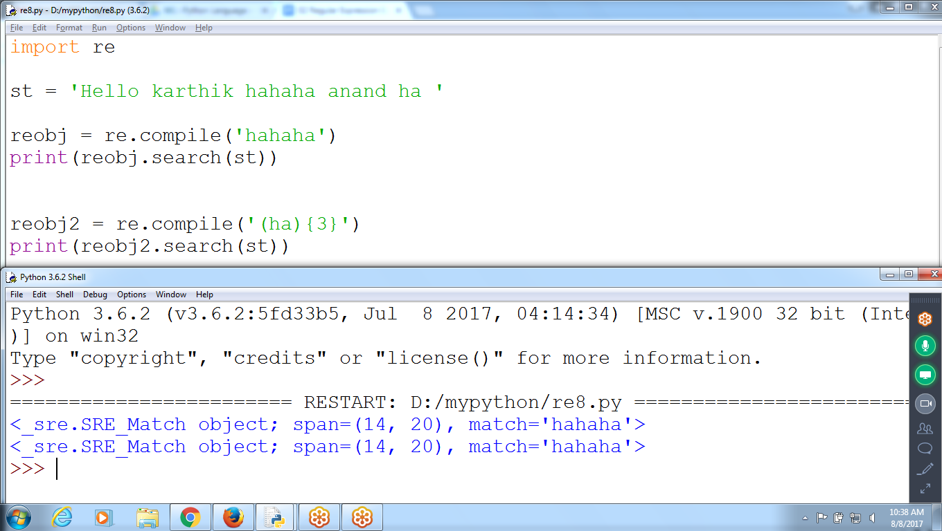

**12) Checking for Phone Number :: \d\d\d-\d\d\d-\d\d\d\d'**

**Ex: 970-470-3579**

**#phone number must be \d\d\d-\d\d\d-\d\d\d\d**

**import re**

**st = 'My Number is 123-456 or contact me 994-999-0032 ok bye '**

**reobj = re.compile('(\d\d\d-){2}\d\d\d\d')**

**print(reobj.search(st))**

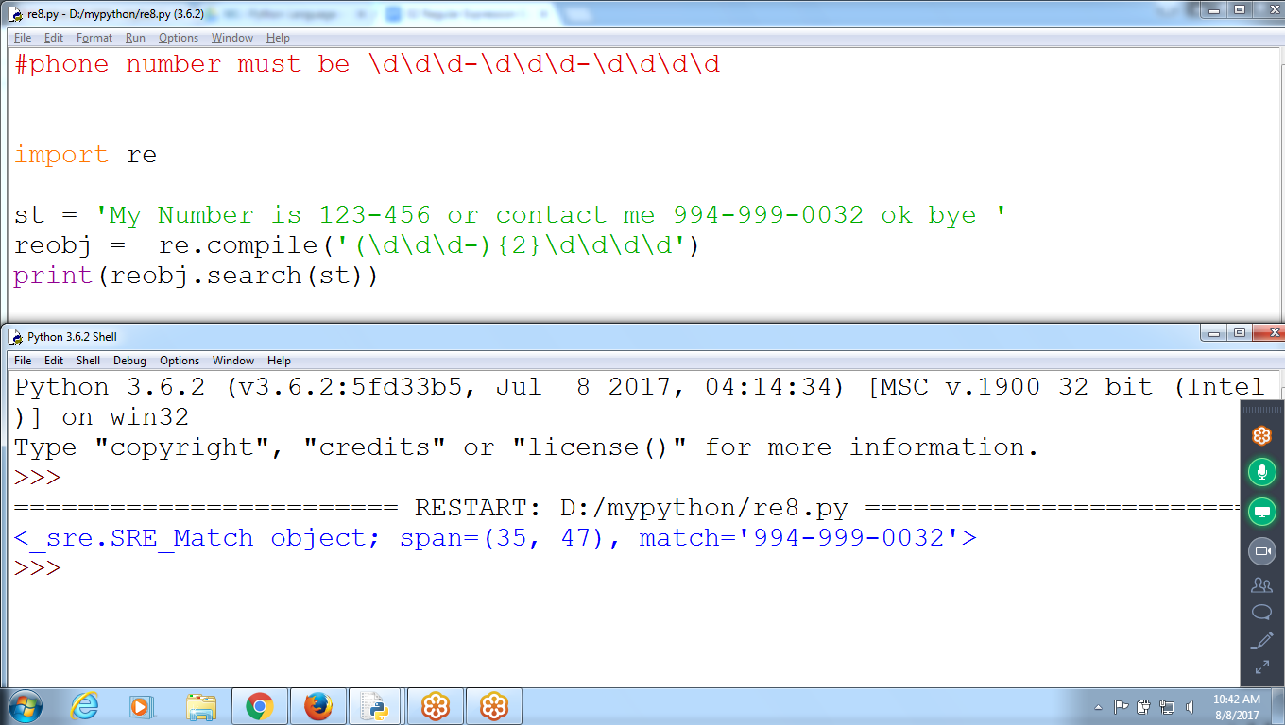

**reobj = re.compile('\d\d\d-\d\d\\d-\d\d\d\d')**

**13) Phone Numbers :: must be 3 sets**

**Ex: Collection of 3 Numbers in the format of 999-999-9999 with**

**Comma Separated Optional**

**using ?**

**>>> reobj = re.compile('(\d\d\d-\d\d\d-\d\d\d\d,){3}')**

**>>> reobj = re.compile('(\d\d\d-\d\d\d-\d\d\d\d(,)?){3}')**

**>>> reobj = re.compile('((\d\d\d-){2}-\d\d\d\d(,)?){3}')**

**>>> reobj = re.compile(r'(\d\d\d-\d\d\d-\d\d\d\d(,)?){3}')**

**>>> reobj.search(' My number 470-970-4789,970-470-3579,999-470-3579 Prem ')**

**<_sre.SRE_Match object; span=(11, 49), match='470-970-4789,970-470-3579,999-470-3579'>**

**>>>**

**#Collection of 3 sets Numbers in the format of**

**#999-999-9999 with BLANK Space or , Separated**

**import re**

**st = ' My number 470-970-4789,970-470-3579,999-470-3579 Prem '**

**reobj = re.compile('(\d\d\d-\d\d\d-\d\d\d\d(,)?){3}')**

**print(reobj.search(st))**

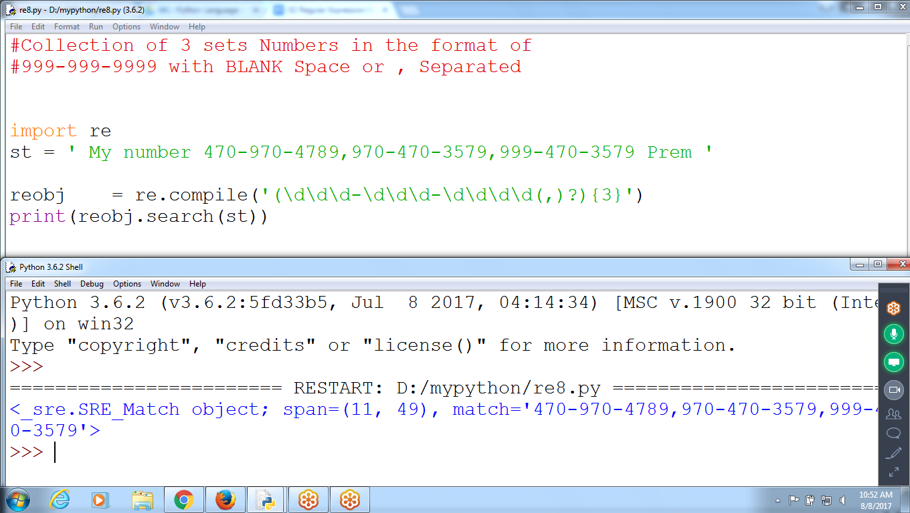

**Ex: Collection of 3 Numbers in the format of 999-999-9999 with BLANK Space Separated Optional using ?**

**>>> reobj = re.compile(r'(\d\d\d-\d\d\d-\d\d\d\d( )?){3}')**

**>>> reobj.search(' My number 470-970-4789 970-470-3579 999-470-3579 Prem ')**

**<_sre.SRE_Match object; span=(11, 50), match='470-970-4789 970-470-3579 999-470-3579 '>**

**>>>**

**14) IN Phone**

**Number Code is Optional, Separated with ‘,’ and with 3 sets**

**>>> reobj = re.compile(r'((\d\d\d-)?\d\d\d-\d\d\d\d(,)?){3}')**

**>>> reobj.search(' My number 970-4789,970-470-3579,470-3579 Prem ')**

**<_sre.SRE_Match object; span=(11, 41), match='970-4789,970-470-3579,470-3579'>**

**>>>**

**15) Minimum and MAximum Repetitions**

**import re**

**st = ' Hello Prem hahahahaha '**

**reobj = re.compile('(ha){3,5}')**

**print(reobj.search(st))**

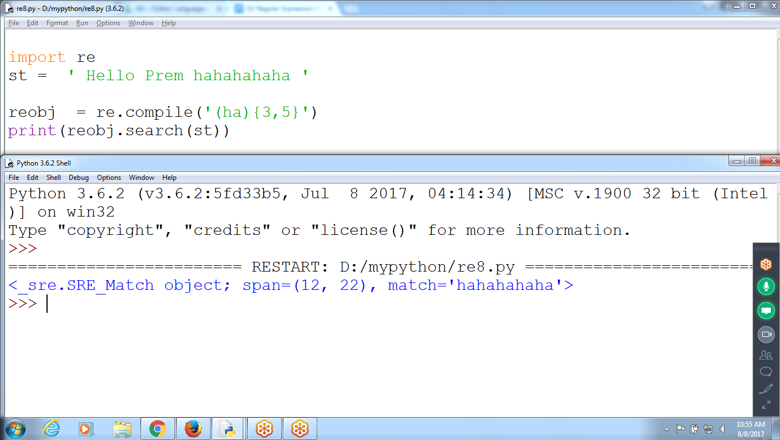

>>>> reobj = re.compile(r'(ha){3,5}')

>>>

>>>

>>>

>>> reobj.search(' Hello Prem hahahahaha ')

<_sre.SRE_Match object; span=(12, 22), match='hahahahaha'>

>>>

>>>

>>> reobj.search(' Hello Prem hahahahello kumar aha ')

<_sre.SRE_Match object; span=(12, 18), match='hahaha'>

>>>

>>>

>>> reobj.search(' Hello Prem hahahello kumar aha ')

>>>

>>>

>>> reobj.search(' Hello Prem hahahahahahahahello kumar aha ')

<_sre.SRE_Match object; span=(12, 22), match='hahahahaha'>

>>>

**14) Minimum 3 Times and NO Maximum**

>>> reobj = re.compile(r'(ha){3,}')

>>> reobj.search(' Hello Prem hhhhahh john ')

>>> reobj.search(' Hello Prem hahahahahahahahahahahah john ')

<_sre.SRE_Match object; span=(12, 34), match='hahahahahahahahahahaha'>

>>>

**15) Minimum 3 Digits and maximum 5 Digits in a string**

>>> reobj = re.compile(r'(\d){3,5}')

>>> reobj.search('ram 123456')

<_sre.SRE_Match object; span=(4, 9), match='12345'>

>>> reobj.search('raju 12abc xy987 raj ')

<_sre.SRE_Match object; span=(13, 16), match='987'>

>>> reobj.search('raju 12abc xy98 raj ')

**Checks minimum 3 Digits**

>>> reobj = re.compile(r'(\d){3,5}?')

>>> reobj.search('raju 12abc xy1234567898 raj ')

<_sre.SRE_Match object; span=(13, 16), match='123'>

**Search() : returns Match Objects**

**findall() : returns list of Strings Matches**

>>> reobj = re.compile(r'\d\d\d-\d\d\d-\d\d\d\d')

>>> st = ''' Harsh technologies 970-470-3579 and

KarthikSir 994-999-0032

office number 123-456-7999 can contact any number '''

>>> reobj

re.compile('**\\d\\d\\d-\\d\\d\\d-\\d\\d\\d\\d')**

>>> **reobj.search(st)**

<_sre.SRE_Match object; span=(20, 32), match='970-470-3579'>

>>> **reobj.findall(st)**

['970-470-3579', '994-999-0032', '123-456-7999']

>>>

**While Using Grouping**

>>> st = ''' Harsh technologies 970-470-3579 and

KarthikSir 994-999-0032

office number 123-456-7999 can contact any number '''

>>> reobj = re.compile(st)

>>> reobj = re.compile(r'(\d\d\d)-(\d\d\d-\d\d\d\d)')

>>> reobj.search(st)

<_sre.SRE_Match object; span=(20, 32), match='970-470-3579'>

>>> reobj.findall(st)

[('970', '470-3579'), ('994', '999-0032'), ('123', '456-7999')]

>>>

**\d : 0 to 9**

import re

st = ' Hello Prem123 hah45678ahahaha '

reobj = re.compile('\d\d\d')

print(reobj.search(st))

reobj2 = re.compile('(4|5|6){3}')

print(reobj2.search(st))

